4 - Convolution, Viterbi

Coding allows errors introduced by transmission to be detected and maybe even corrected.  
We deal with codes for AWGN and also for fading channels.  
Link Capacity: codes can go very close to the theoretical Shannon capacity limit.   
Theoretically it is possible to transmit information at any rate R where R <= C

Performance: the amount of error reduction for specific coding:  
 in AWGN it is coding gain  
 in fading environment its diversity gain

**Convolutional coder:**Watch this: <https://www.youtube.com/watch?v=kRIfpmiMCpU> (Draw table and also scheme of coder – trellis optional I guess but helpful for viterbi)

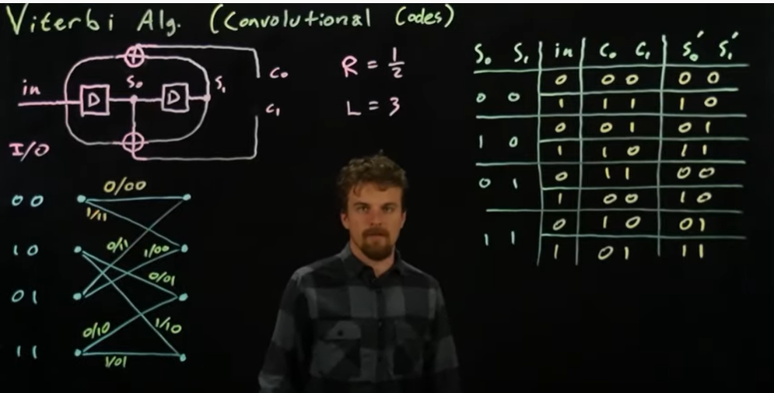

**Viterbi decoder:**  
<https://www.youtube.com/watch?v=dKIf6mQUfnY>

